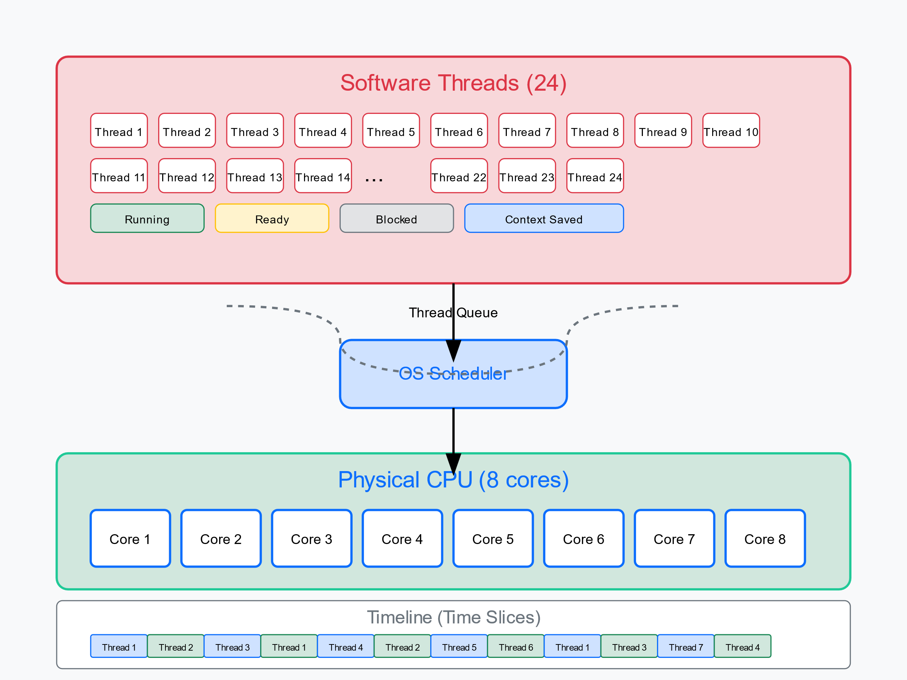

Time Slicing in Operating Systems
Time slicing is a fundamental concept in multitasking operating systems. It allows the CPU to switch between multiple software threads even though the physical processor cores are limited.

Basic Concept
In your scenario:
- 8 physical CPU cores (hardware threads)
- 24 software threads needing execution time

How Time Slicing Works
- Thread States:
  - Running: Currently executing on a CPU core
  - Ready: Waiting for CPU time
  - Blocked: Waiting for a resource or event
  - Context Saved: Temporarily stopped but state preserved
- Context Switching Process: When a thread's time slice expires: a) The OS scheduler interrupts the thread b) Saves the thread's state (registers, program counter, etc.) c) Selects another thread from the ready queue d) Loads the new thread's saved state e) Resumes execution of the new thread

Concrete Example
Let's walk through an example to illustrate how a thread gets paused and resumed:

Example: Thread Processing a File Upload
Imagine Thread-1 is handling a file upload for a web application:
Time 0ms: Thread-1 begins processing a file upload (allocated to Core 1)
Time 20ms: Thread-1 has processed 20% of the file
Time 25ms: Thread-1's time slice expires!
What happens at time 25ms:
- The OS scheduler triggers an interrupt
- Core 1 stops executing Thread-1's instructions
- The OS saves Thread-1's complete execution state:
  - Program counter (pointing to exact instruction)
  - CPU registers
  - Memory state
  - File handles
  - All variables/data
- The scheduler selects Thread-8 (which was waiting in the ready queue)
- Thread-8's previously saved state is loaded onto Core 1
- Thread-8 begins execution on Core 1
Time 25ms: Thread-8 starts running on Core 1
Time 50ms: Thread-8's time slice expires
Time 50ms: OS saves Thread-8's state
- Later, Thread-1 gets another turn:
Time 75ms: Thread-1's saved state is restored to Core 1
Time 75ms: Thread-1 resumes execution EXACTLY where it left off
Time 75ms: Thread-1 continues processing the file from 20% completion
From Thread-1's perspective, it appears as if it ran continuously without interruption - it has no awareness that it was paused.

Architecture Components
The key elements involved in time slicing:
- Timer Hardware: Generates interrupts at regular intervals (e.g., every few milliseconds)
- Context Save Area: Memory where thread state is preserved
- Scheduler: Manages the thread queue and decides which thread runs next
- Dispatcher: Performs the actual context switch operations

Why Time Slicing Works
Time slicing creates the illusion of parallelism through these mechanisms:
- Fast Context Switching: Modern CPUs can switch contexts in microseconds
- Preemptive Multitasking: The OS can interrupt threads at any time
- Priority Scheduling: Important threads get more CPU time
- Memory Isolation: Each thread operates in its own memory space

Common Time Slice Durations
- Desktop/Server OS: 10-100ms time slices
- Real-time systems: 1-10ms time slices
- Mobile devices: Variable time slices (power optimization)

